**Zeiss Axiovert 200 MAT w/ Axiocam MRc5 microscope**

**Standard Operation Procedure**

1. Microscope Layout

Stage

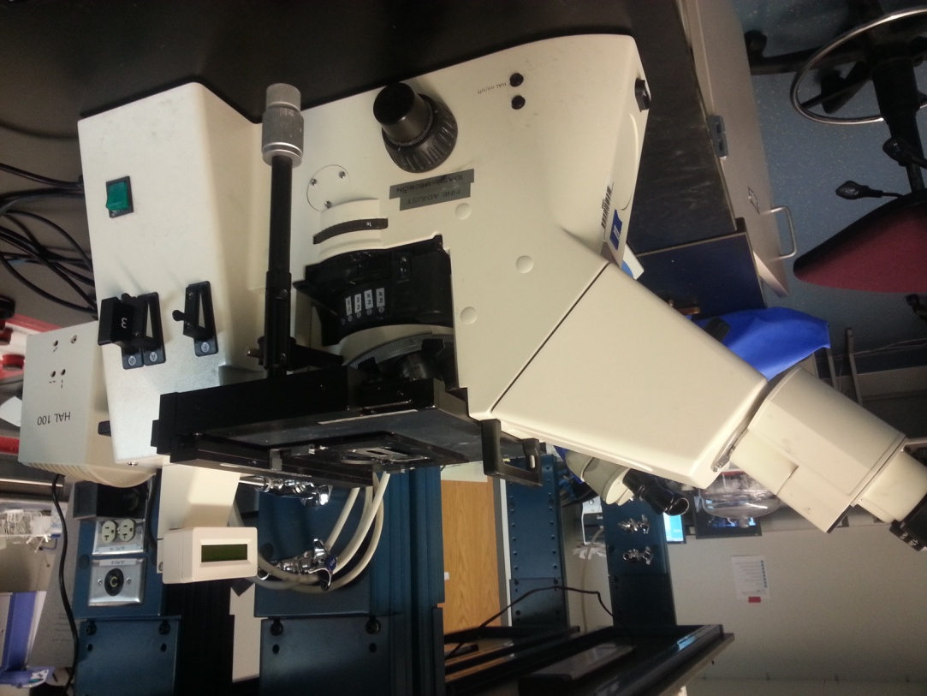

Manual adjustment knob: Forward/Back Left/Right

LCD Display

Halogen Lamp on/off switch

Toggle switch for illumination intensity

Course/Fine focusing knobs

On/Off Switch

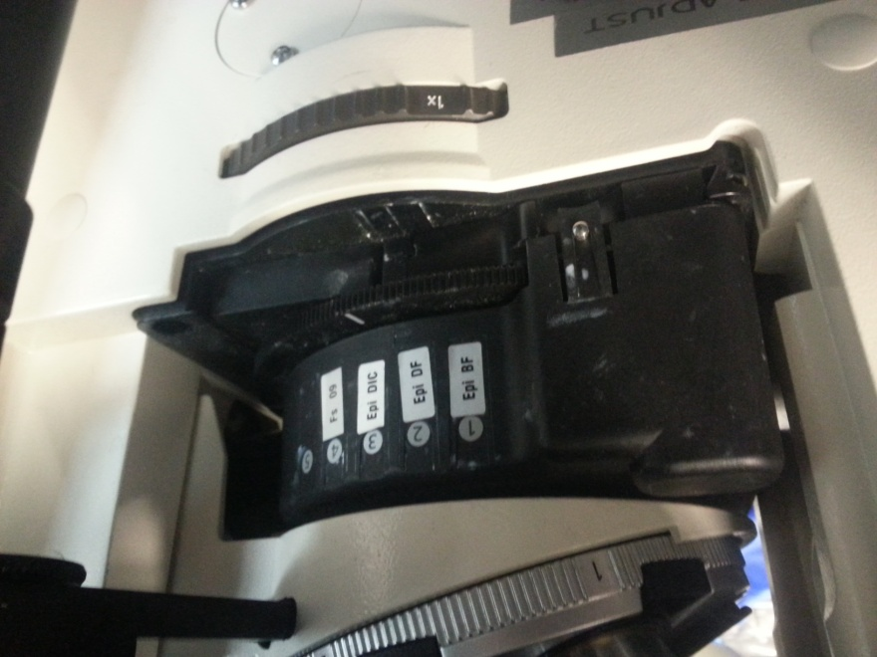

Revolving objective nosepiece

Imaging mode selector: BF

DF

DIC

Optovar turret selector wheel: 1x or 1.5x

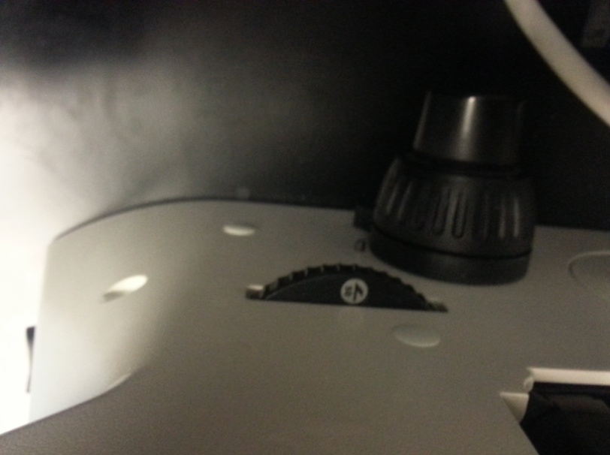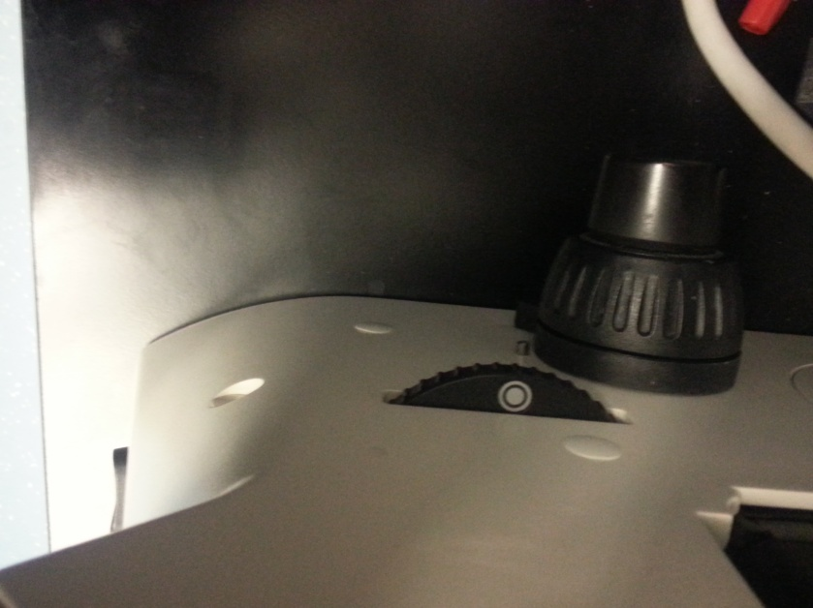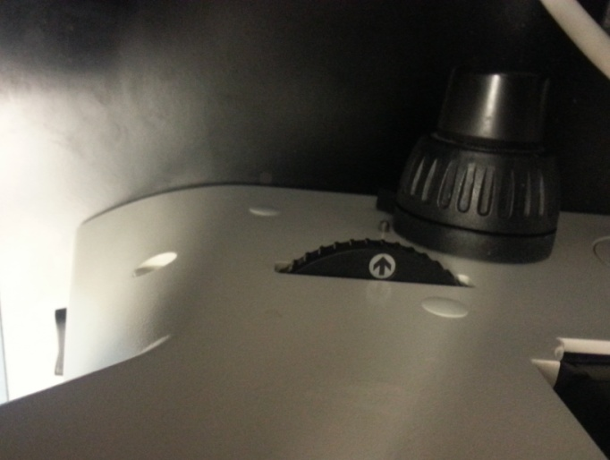

Selector wheel for camera port: Microscope and computer, Microscope only, Computer only.

1. Microscope Basic Operation: Microscope View ONLY
   1. 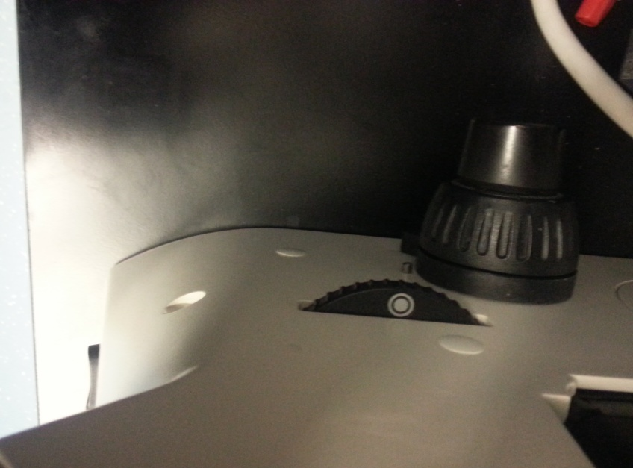Power microscope on using the On/Off Switch
   2. Verify that the Selector wheel for camera port is set to Microscope Only
   3. Check that light is coming from the microscope up through the stage
   4. Selective desired objective nosepiece. Note: It is usually best to start with the lowest and then increase the objective nosepiece after focusing
   5. Place specimen on sample stage in region of light
   6. Use the Manual adjustment knob and Course/Fine focusing knob to find and focus on region of interest.
   7. Image brightness can be adjusted using the illumination intensity toggle switch.
   8. For more brightness and image adjustment options, see complete user manual located in a drawer below microscope.
2. Microscope Basic Operation: Computer View and/or Microscope
   1. Power microscope on using the On/Off Switch
   2. Check that light is coming from the microscope up through the stage
   3. Selective desired objective nosepiece. Note: It is usually best to start with the lowest and then increase the objective nosepiece after focusing
   4. Place specimen on sample stage in region of light
   5. Use the Manual adjustment knob and Course/Fine focusing knob to find and focus on region of interest.
   6. 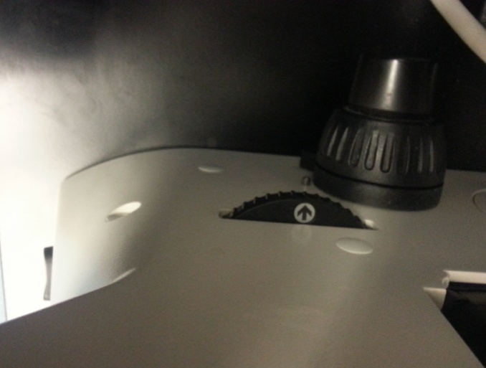Image brightness can be adjusted using the illumination intensity toggle switch.
   7. Verify that the Selector wheel for camera port is set to Computer Only

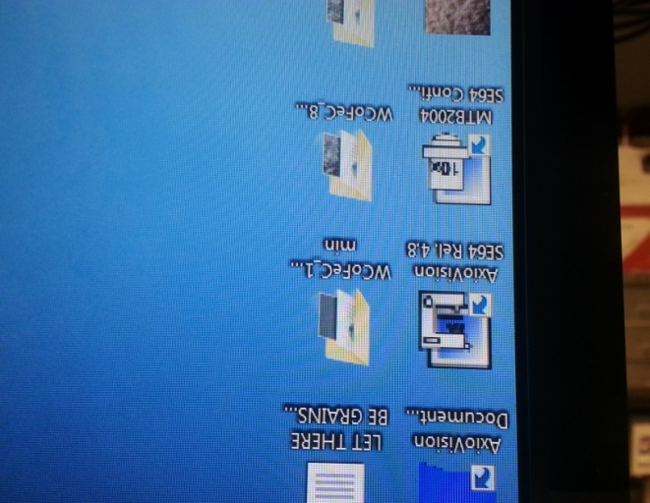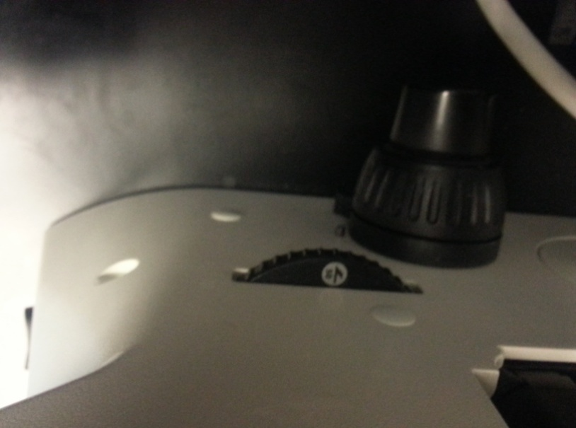 or Microscope and Computer

* 1. 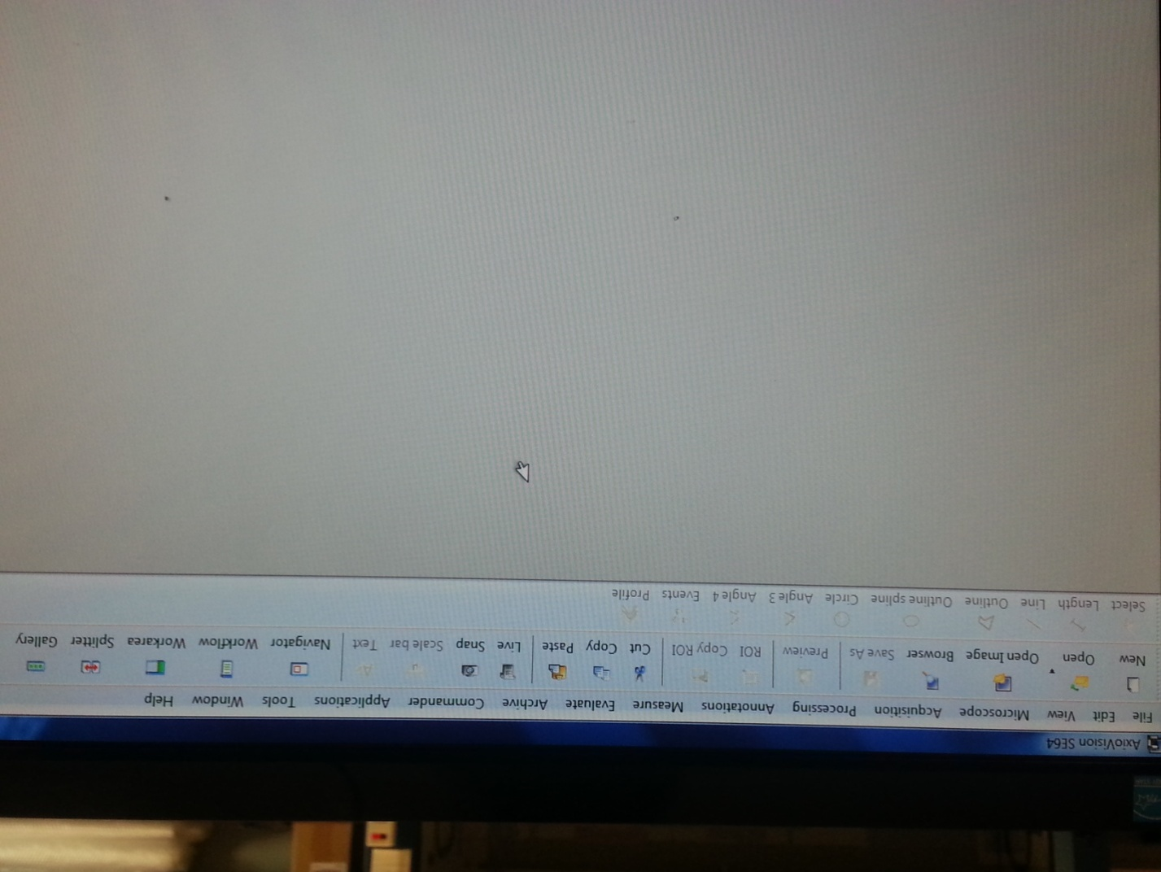Open AxioVision SE64 Rel. 4.8 Software
  2. Click Live on the toolbar
  3. Use the Manual adjustment knobs to move

area of interest into computer screen view

* 1. Select Snap to capture image
  2. Scale bar and text can be added using the software
  3. Save image

If you have any questions, ask for assistance or consult complete operating manual located in a drawer below the microscope.